

**\*\*Phase 1**: _"I'd like to Teach the World to `Ping`"_**

**Answer: -**

**I) Commands**

I have used fping command to determined only Hollywood office IP ranges to see which ip address was alive and accepting connections.

|  |  |
| --- | --- |
| **IP RANGE** | **LOCATION + SERVER TYPE** |
| 15.199.95.91/28 | Hollywood Database Servers |
| 15.199.94.91/28 | Hollywood Web Servers |
| 11.199.158.91/28 | Hollywood Web Servers |
| 167.172.144.11/32 | Hollywood Application Servers |
| 11.199.141.91/28 | Hollywood Application Servers |

I was using fping with two different options to see which one work well.

a) fping -**g** <ipaddress> :- This option was showing me all ip address alive & unreachable.

b) fping -**ag** <ipaddress> This option was showing me only alive ip address, which I thought was less time consuming and direct search and show the accepting connection ip address.

**II) Vulnerabilities Discovered**

I have found one potential vulnerability IP address which was **167.172.144.11** this ip address was responding as alive during fping command prosses and all rest ip address were unreachable.

**III) Findings Associated to a Hacker**

I am unable to determine at Phase 1 if **167.172.144.11** ip address is associate with any attacks or hacker but this ip address alive and that’s why this is a vulnerability.

**IV) Mitigation Recommendations**

As per RockStar Corporation instructions, they don’t want any of their servers accept connection and respond to any request. As recommend to all servers should not accepting

any unknown connection and all port should be close for them.

**V) OSI layer**

This occurred on the Layer 3 network layer as Ping uses IP addresses and IPs are used on the Network Layer of the OSI model.

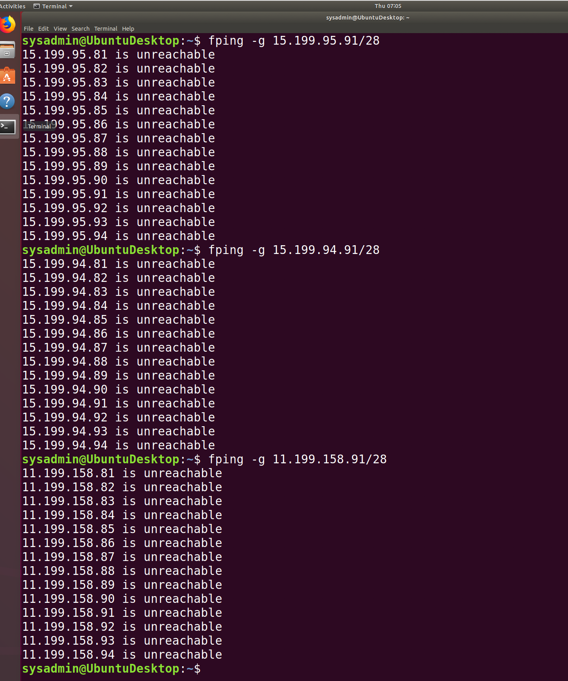

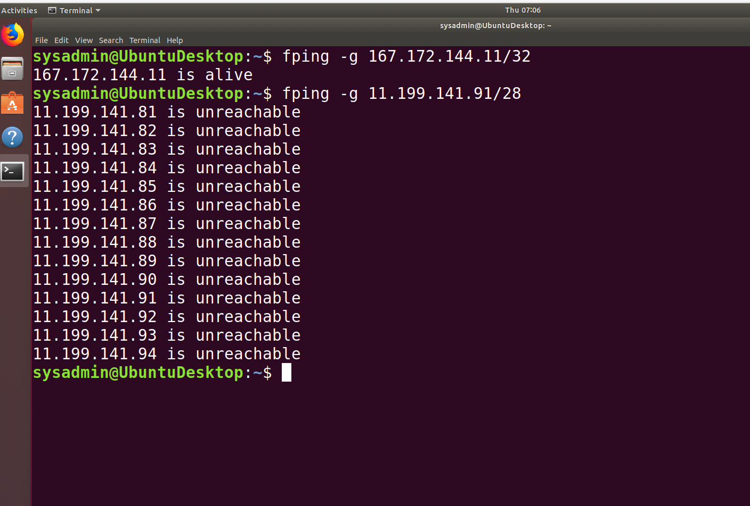

**This command using fping -ag.**

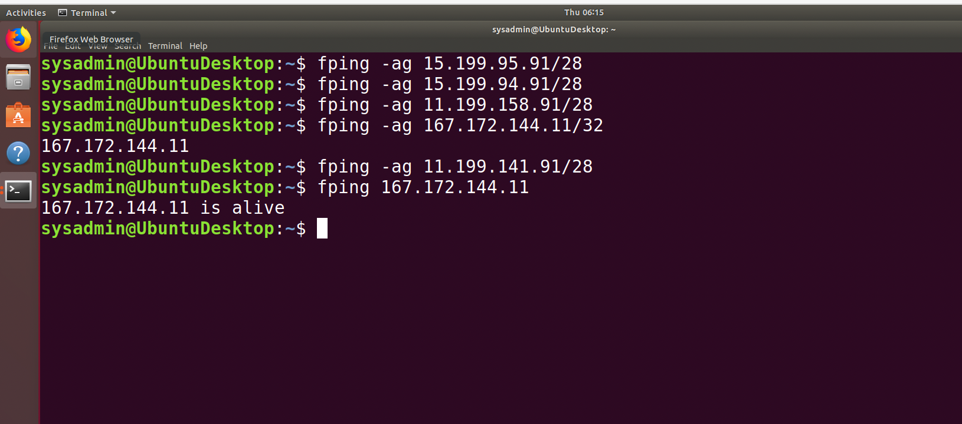



**\*\*Phase 2**: _"Some `Syn` for Nothin`"_**

**Answer: -** In phase 2 I did a SYN scan to check which ports are open.

**I) Commands**

Please find below the command I used to find open ports

“**sudo nmap -sS 167.172.144.11”**

**II) Vulnerabilities Discovered**

After I ran command, this determined that the SSH port 22 is open and accepting connections and it is potential vulnerability.

**III) Findings Associated to a Hacker**

It is not possible to determine any evidence of a hacker at the Phase 2.

**IV) Mitigation Recommendations**

As recommend RockStar Corporation should do further investigate on port 22, to find out more evidence about hacker.

**V) OSI layer**

This occurred on the Layer 4 – Transport of the OSI model, for reference Transport layer puts data onto the network and assigns source and destination ports.

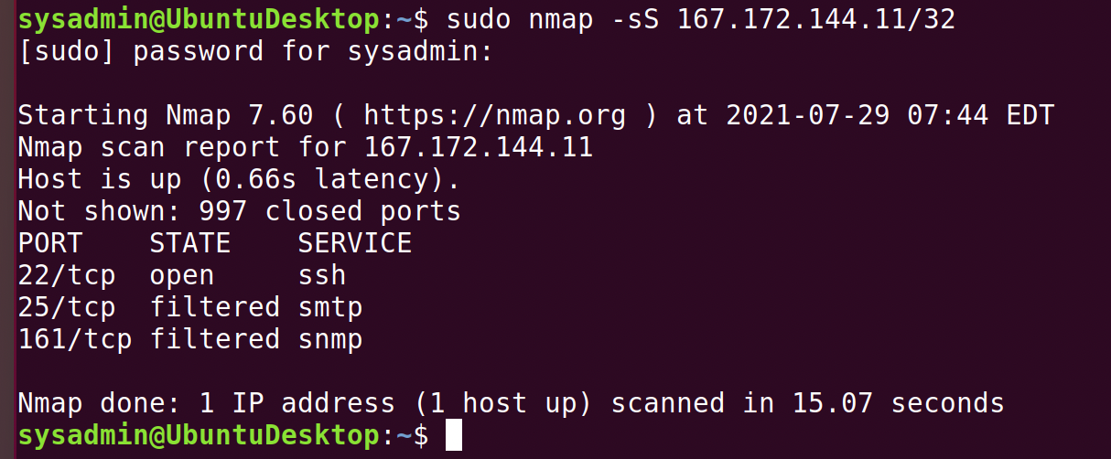



**\*\*Phase 3**: _"I Feel a `DNS` Change Comin' On"_**

**Answer: -**

**I) Commands**

Please find below the command I used to find “unknown domain”

1. “ssh jimi@167.172.144.11 -p 22” (This command to login as jimi user)
2. “cd /etc” (This command to go etc folder)
3. “grep -r rollingstone.com” (This command to find if any file having rollingstone.com ip address)

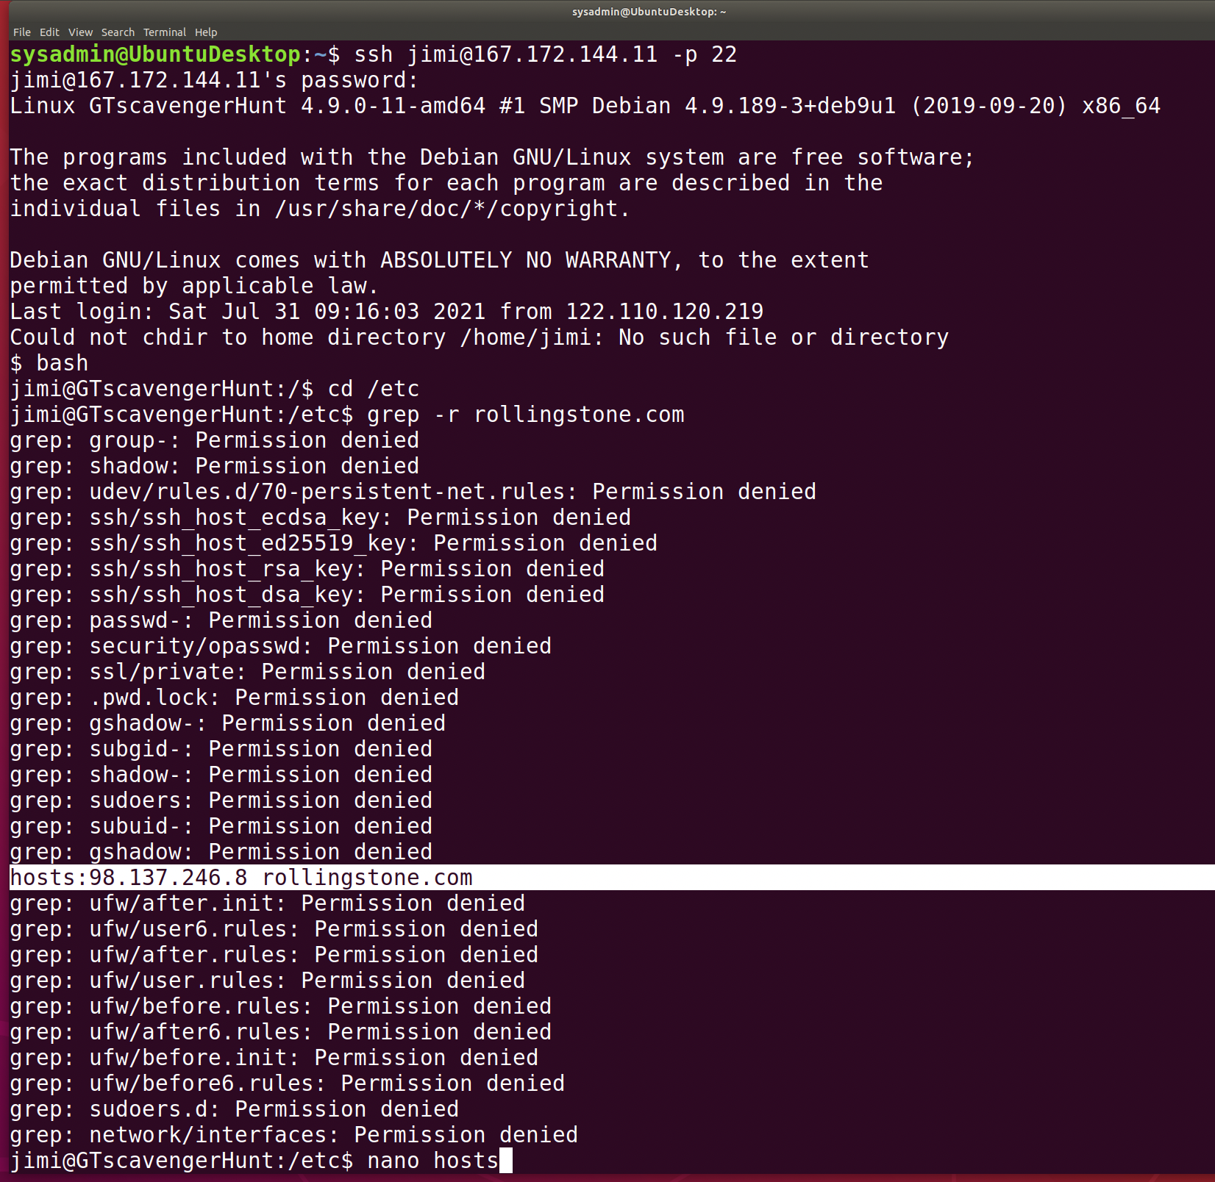

1. **“nano hosts” (This command to see hosts file have the ip address is set to ﻿rollingstone.com﻿)**

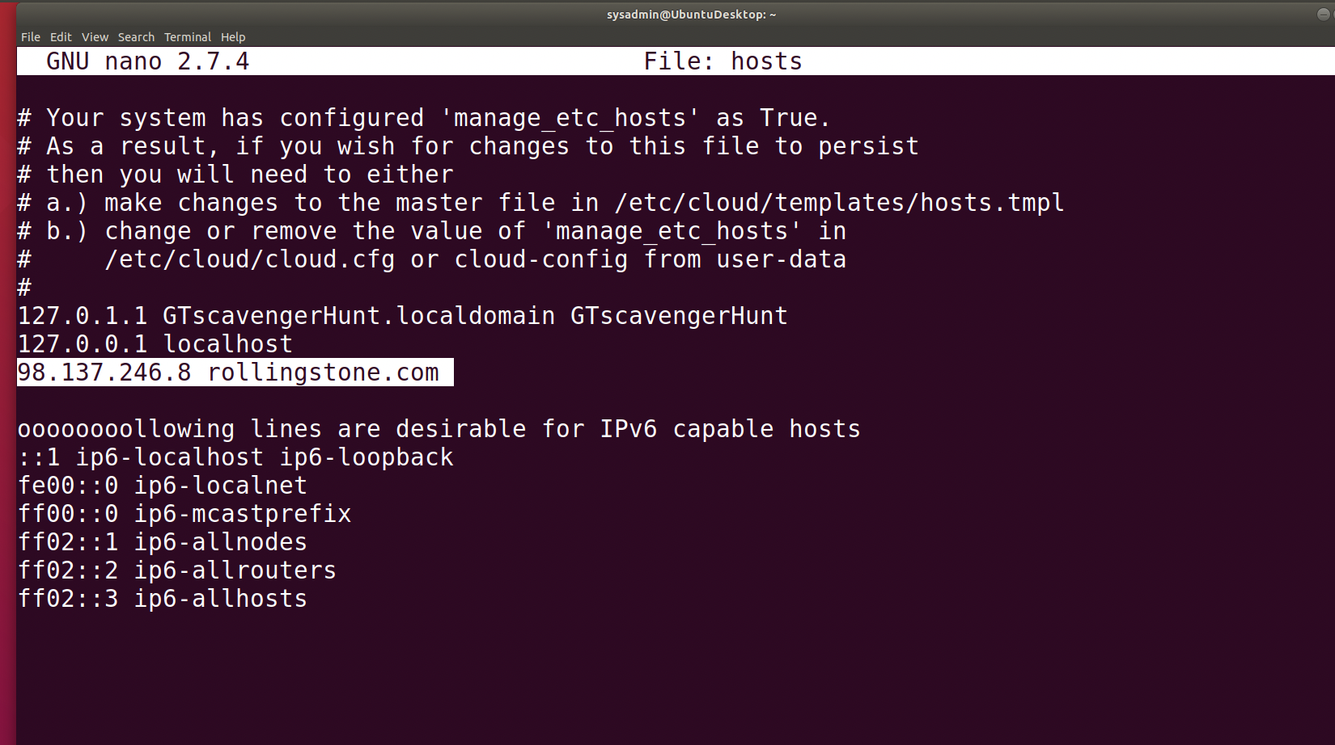

**II) Vulnerabilities Discovered**

I logged in as ssh jimi@167.172.144.11 -p 22 and I tried to find the record entry that is set to `rollingstone.com` and I found it after I ran command grep -r rollingstone.com and I found there is file name **hosts** in etc folder **and it has** ip address. After nano to hosts file I found out the﻿ rollingstone.com is being redirected to **98.137.246.8** and this is a vulnerability as this ip address is not belong to RockStar Corporation.

**III) Findings Associated to a Hacker**

I ran nslookup to **98.137.246.8,** and I was able to determine the right domain name showed

that the domain was **unknown.yahoo.com.**

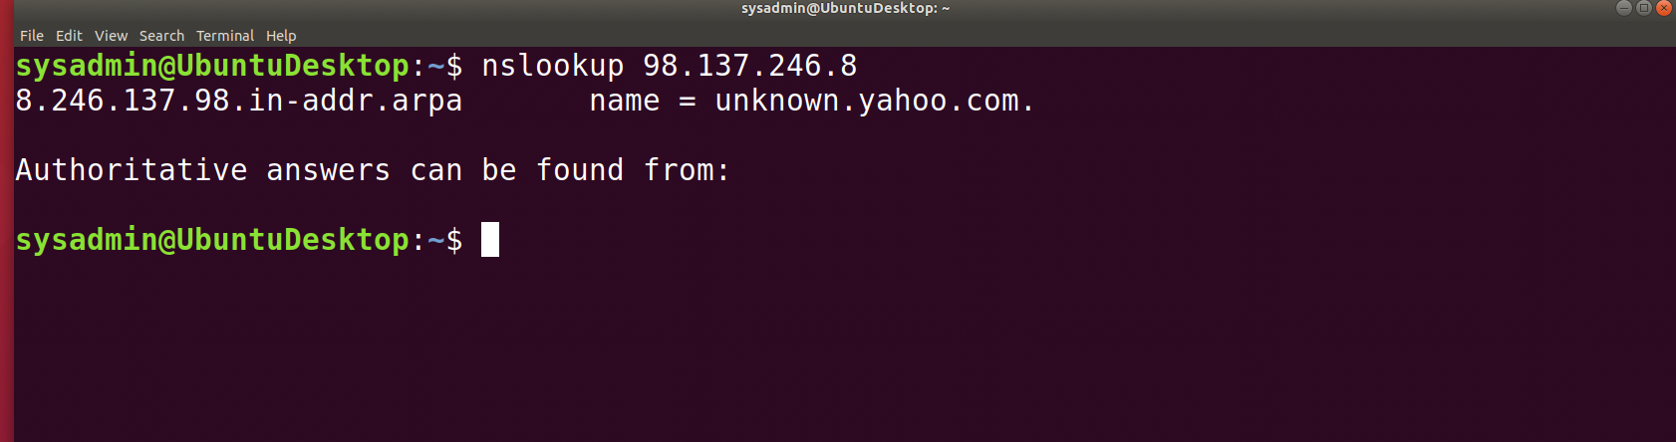



**IV) Mitigation Recommendations**

As recommend RockStar Corporation should disable the port 22 to prevent security breaches.

**V) OSI layer**

This occurred on the Layer 7 – Application of the OSI model, as nslookup is a command-line tool that allows us to easily check the DNS records of any domain and DNS is a protocol that sits at the application-level and it is a separate application in itself.

**\*\*Phase 4**: _"Sh`ARP` Dressed Man"_**

**Answer: -**

**I) Commands -** Please find below the command to find packet captures location and suspicious activity data in Wireshark.

1. ls -lt (This command to check any other file was generated on same day).
2. Cat packetcaptureinfo.txt (This command to check what is in side file)
3. `http.request.method == "POST" (This filter I have used in Wireshark to see if hacker post any message or did any suspicious activity).

**II) Vulnerabilities Discovered**

I continued within the Rockstar server as ssh user jimi and cd in etc folder to check if any file or note left by hacker. As I ran command ls -lt I found out there is file packetcaptureinfo.txt was made on the same day as hosts file updated, then I cat in to packetcaptureinfo.txt file and led to google drive file link.

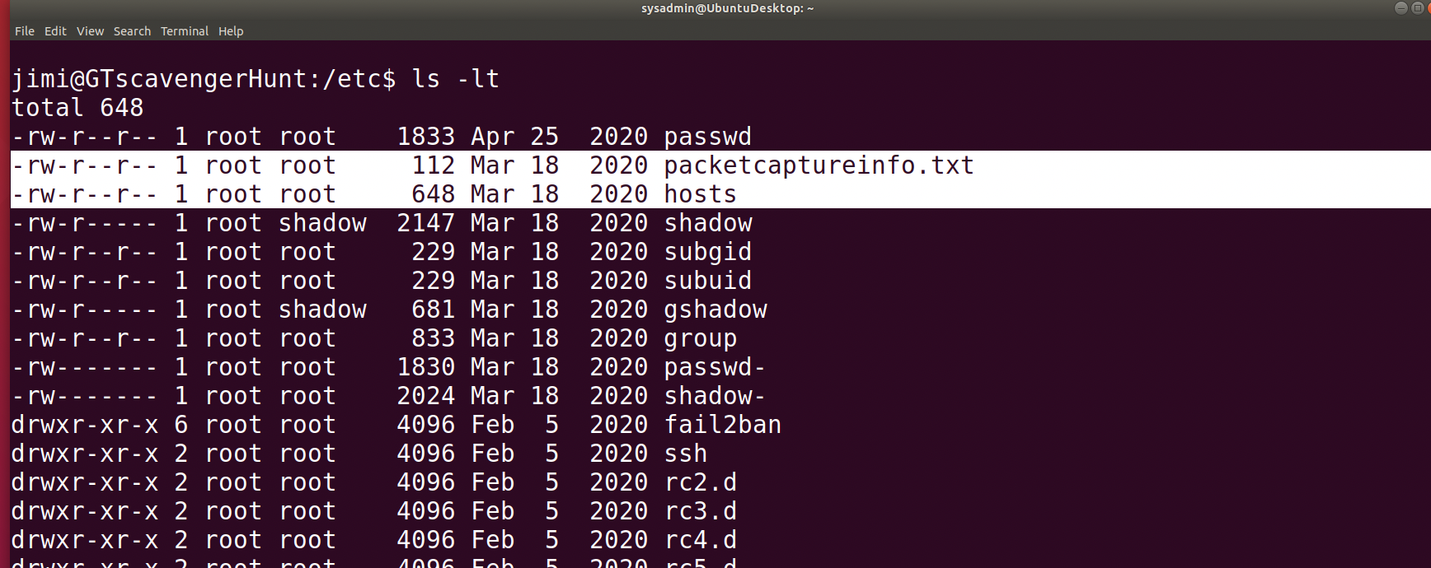

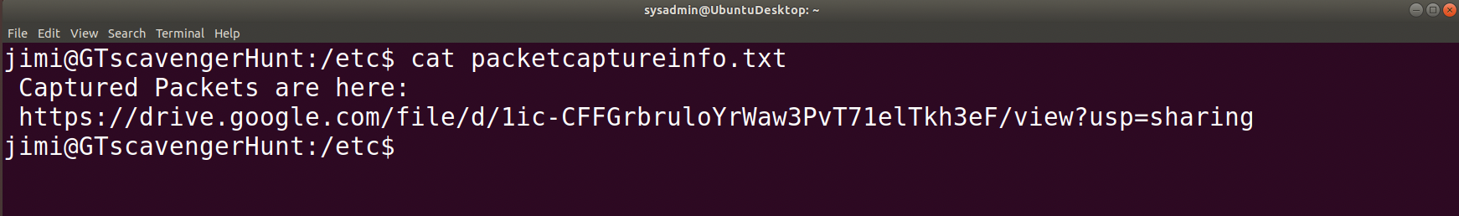



**III) Findings Associated to a Hacker**

I download the file and open in Wireshark to see if hacker post any message or did any suspicious activity and I filter ARP. As I found that hacker is doing ARP spoofing to get MAC address and hacker got the access as well, I found that data was send and received from 192.168.47.200 and there were duplicate IP address and hacker’s MAC address is 00:0c:29:1d:b3:b1.

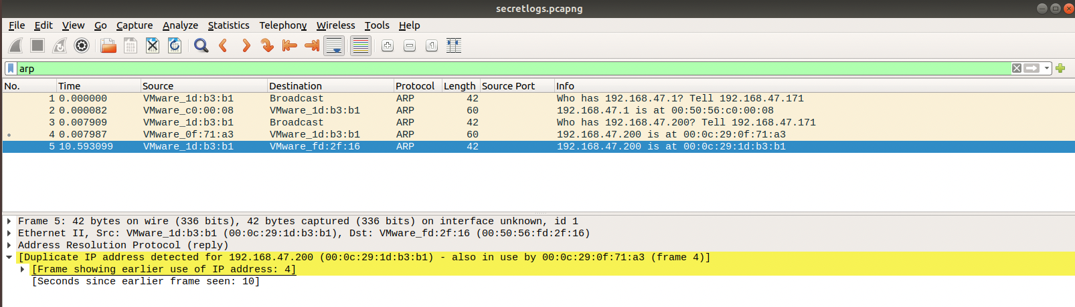

After that I filtered as `http.request.method == "POST" and I discovered that hackers visited to website form page

**(﻿Form item: "redirect" =** [**http://www.gottheblues.yolasite.com/contact-us.php?formI660593e583e747f1a91a77ad0d3195e3Posted=true**](http://www.gottheblues.yolasite.com/contact-us.php?formI660593e583e747f1a91a77ad0d3195e3Posted=true)**)**

Hacker sent an message through gottheblues website form page to Got the Blues Corp saying ﻿

**(Form item: "3<textarea>" = "Hi Got The Blues Corp! This is a hacker that works at Rock Star Corp. Rock Star has left port 22, SSH open if you want to hack in. For 1 Milliion Dollars I will provide you the user and password!")**

This is suspicious activity I found out on Wireshark, hacker was saying to Got the blues corp that port 22 is open and if they want to hack company give hacker 1 million dollars and they will get the user name and password of RockStar Corporation.

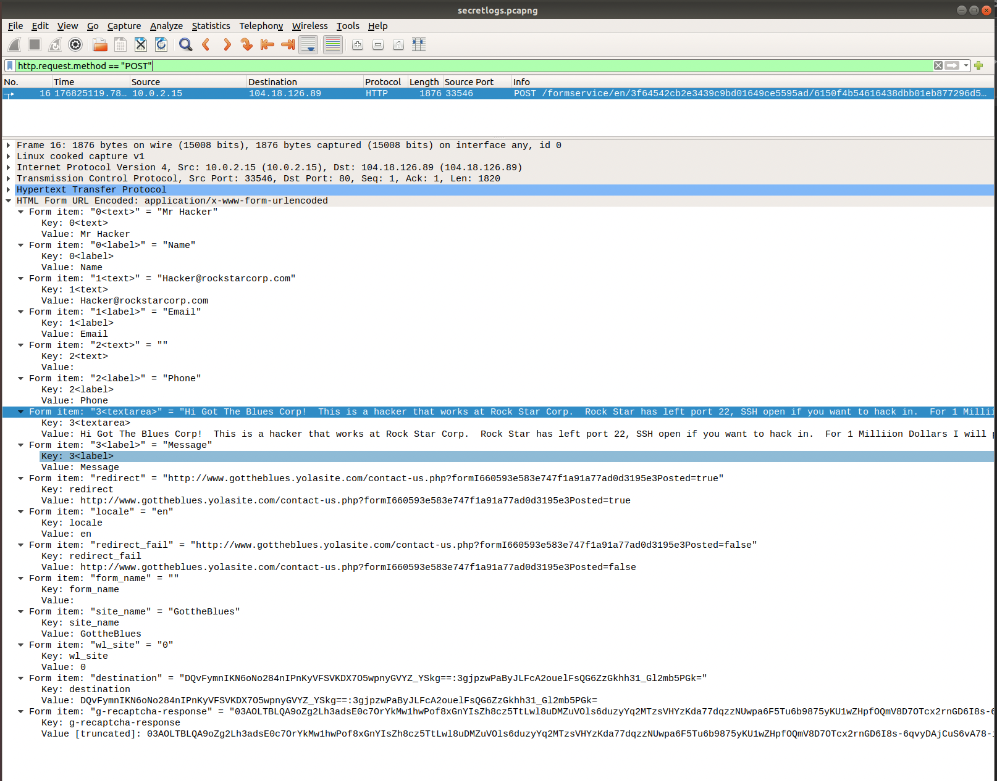

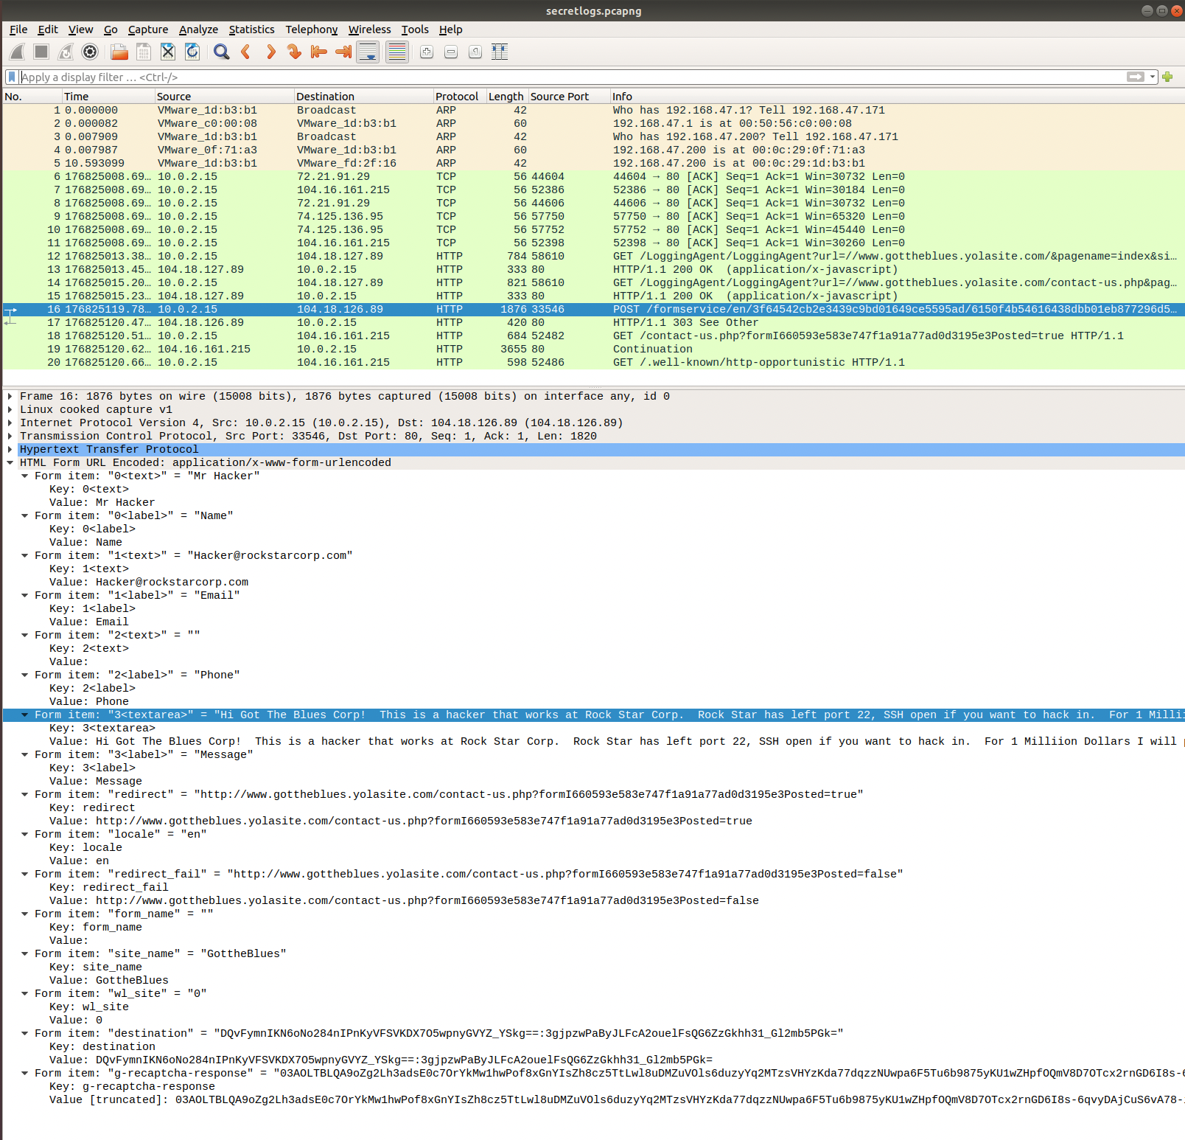

**IV) Mitigation Recommendations**

As recommend RockStar Corporation should create static ARP entry to reduce risk of ARP

spoofing and also cyber security analyst should inspect daily all ports and create a schedule for crontab job and also do weekly or daily audit to see if anyone is doing ARP spoofing to get MAC address.

**V) OSI layer**

There are two OSI layer for phase 4.

1. First occurred on the Layer 2 - Data Link OSI model, as ARP is a communication protocol and its transfer network traffic within local network and I discovered that hacker was sending and receiving MAC address so that was ARP spoofing.
2. Second occurred Layer 7 – Application OSI model, as I discovered hackers sent an message using HTTP website that showed hacker activity and hackers purposes and HTTP is an application layer protocol used for transferring information between computers on the World Wide Web.

Thank you,

Aziz Somani